**GAME PORTAL**

*Submitted by:*

HARI OM NARAYAN

**ABSTRACT**

In today’s modern world , we play a lot of games in which many of them are desktop as well as mobile based . One of such mobile game is Temple run which is very popular and is played worldwide .

In this project I have tried to maintain a similar database regarding it which contain information as player its score details and the rewards the player achieves. It also contain information like game characters , his/her name , special ability and the different game map . The project includes various character opt by the player and choosing different game map and its respective scores and ranks in the database.

**TABLE OF CONTENTS**

|  |  |  |
| --- | --- | --- |
| Index | **CHAPTERS** | Page No |
| 1 | INTRODUCTION | 7 |
| 2 | LITERATURE SURVEY | 9 |
| 3 | SYSTEM REQUIREMENTS SPECIFICATIONS | 10 |
| 4 | DESIGN | 11 |
| 5 | RESULT AND SNAPSHOTS | 12 |
| 6 | CONCLUSIONS | 16 |
| 7 | REFERENCES | 16 |

**CHAPTER 1: INTRODUCTION**

* 1. Background
  2. Brief history of Technology/concept
  3. Applications
  4. Research motivation and Problem statement
     1. Research Motivation
     2. Statement of the Problem

**CHAPTER 2: LITERATURE SURVEY**

* 1. Study of Tools/Technology

**CHAPTER 3: SYSTEM REQUIREMENTS SPECIFICATIONS**

3. System Requirements

3.1 Hardware Requirements

3.2. Software Requirements

**CHAPTER 4: DESIGN**

4.1 Dataflow Diagram

4.2 ER Diagram

4.3 Activity Diagram

**CHAPTER 5: CONCLUSIONS**

**CHAPTER 6: REFERENCES**

**INTRODUCTION**

**1.1 Background**

Temple Run is a [3D](https://en.wikipedia.org/wiki/3D_computer_graphics) [endless running](https://en.wikipedia.org/wiki/Endless_running_games) video game developed and published by [Imangi Studios](https://en.wikipedia.org/wiki/Imangi_Studios). The player controls an explorer who has obtained an ancient relic and is running from evil demon monkeys who are chasing him. The game was initially released for [iOS](https://en.wikipedia.org/wiki/IOS) devices on August 4, 2011, and later ported to [Android](https://en.wikipedia.org/wiki/Android_(operating_system)) systems and [Windows Phone 8](https://en.wikipedia.org/wiki/Windows_Phone_8).

The game was a commercial success with positive reviews from critics. The success of the game led to a sequel [Temple Run 2](https://en.wikipedia.org/wiki/Temple_Run_2). Collaborations with [Disney](https://en.wikipedia.org/wiki/Disney) to create Temple Run: Brave and Temple Run: Oz, and a third spin-off in development by Scopely titled, Temple Run: Treasure Hunters as a [match-three](https://en.wikipedia.org/wiki/Match-three) video game. Temple Run also received activity books and a board game, with [Warner Bros. Studios](https://en.wikipedia.org/wiki/Warner_Bros._Studios) talking with Imangi Studios of a possible film adaptation. The success of the game also inspired many similar games that take their own twist but also copycat games that copy the Temple Run gameplay and iconic brand of the original.

**1.2 Brief history of Technology/concept**

This project is about maintaining the database of the game played by the user . It mimicks the original database of the game which stores the information regarding player details its score details and the rewards and objectives and also about the different map name and its level with the character details and other useful details about the character.

In this database there are already users rolled in with thier user_details and score details and the number of rewards they have won in different maps played with different character names more than once.

The admin can update or delete the required user and its properties . For deleting any item the given items must be in the respective tables and it should resemble with the provided details for updating or deleing .

**1.3 APPLICATIONS -**

The application part of this project is to maintain the neat and organised data from where it can be easily operated and also it serves the following objectives:-

* To focus on the links between player ,character .
* To easily find out the scores of different map played by different character.
* To understand the complexity of the game database and its working .

**1.4 Research motivation and Problem statement**

**1.4.1 Research Motivation**

Many users play the game and its necessary to maintain an organised structure of the data and to operate on it . Updating the records of the game and to add new details from any where using the website motivated me to build a project which can handle such problems.

**1.4.2 Statement of the Problem**

Create a Temple run game database which has a user having properties like name , unique id , gender , email_id , login date . The player can opt to choose several character from game characters having their own name and special ability and outfit with different hat types . The game has several maps to play with different difficulty levels . The player is awarded with artefacts and hats after completing an objective in certain map with certain game character .All of the player’s score is recorded which includes number of coins , gems , and the player’s highest score , total distance and rank with the character in a map.

**2. LITERATURE SURVEY**

**2.1 CONCEPTS: -**

**HTML**

Hypertext Mark-up Language (HTML) is the standard mark-up language for documents designed to be displayed in a web browser. Web browsers receive HTML documents from a web server or from local storage and render the documents into multimedia web pages. HTML describes the structure of a web page semantically and originally included cues for the appearance of the document

**CSS**

Cascading Style Sheets (CSS) is a style sheet language used for describing the presentation of a document written in a mark-up language like HTML. CSS is designed to enable the separation of presentation and content, including layout, colours, and fonts. This separation can improve content accessibility, provide more flexibility and control in the specification of presentation characteristics.

**PHP**

PHP is a popular general-purpose scripting language that is especially suited to web development. On a web server, the result of the interpreted and executed PHP code – which may be any type of data, such as generated HTML or binary image data would form the whole or part of a HTTP response.

**MySQl**

MySQL is an open-source relational database management system. We can connect our webpage with MySQL database and can record the data in the backend and can access , modify and monitor that in a efficient way.

**3 . SYSTEM REQUIREMENTS SPECIFICATIONS**

**SOFTWARE USED:**

* Apache
* XAMPP Server

**TECHNOLOGY USED:**

* HTML 5
* CSS
* PHP
* MYSQL
* JAVASCRIPT

**3.1 HARDWARE REQUIREMENTS:**

**OPERATING SYSTEM**: Vista or above (in this project : LINUX(ubuntu) )

**PROCESSOR**: Pentium core 2 duo or above

**MEMORY**:128 MB RAM.

**HARD DISK SPACE**: 20 GB HD

**3.2 SOFTWARE REQUIREMENTS:**

PHP 5.0

MYSQL 3.23x OR ABOVE

APACHE 1.3 OR ABOVE

**4. DESIGN**

**4.1 DATAFLOW DIAGRAM**

LOG IN

SIGN IN

OPERATE TABLE

USER DETAILS

SCORE DETAILS

MAP NAME

CHARACTER DETAILS

REWARDS

OBJECTIVES

CREATE A QUERY

**4.2 ER DIAGRAM**

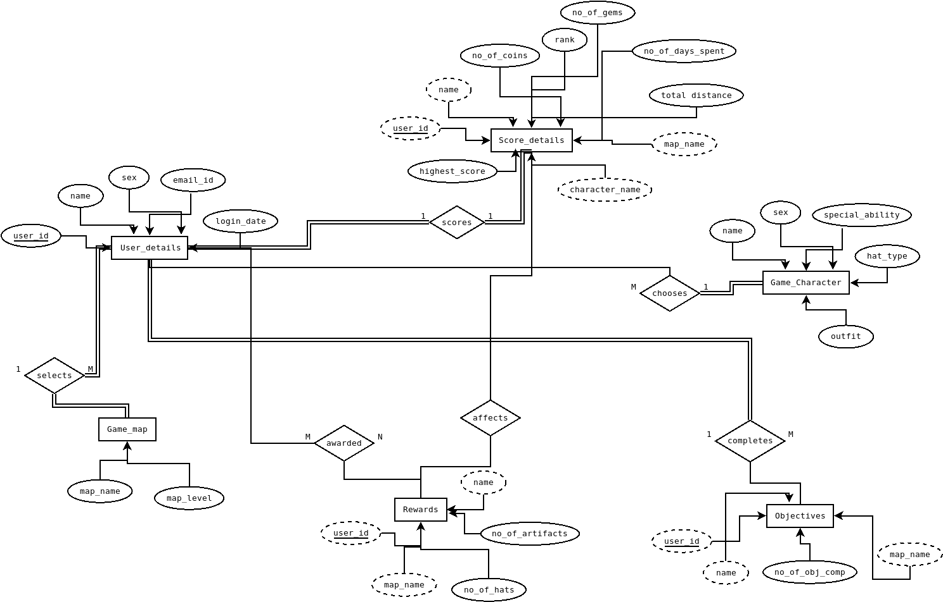

4.3 **RESULT AND SNAPSHOTS**

LOGIN PAGE

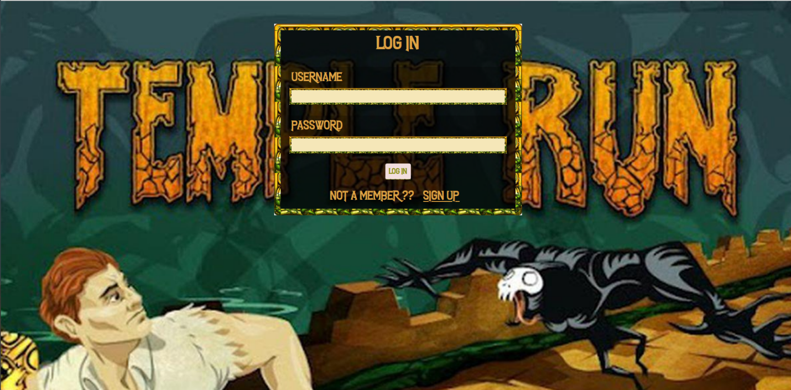

SIGN IN PAGE

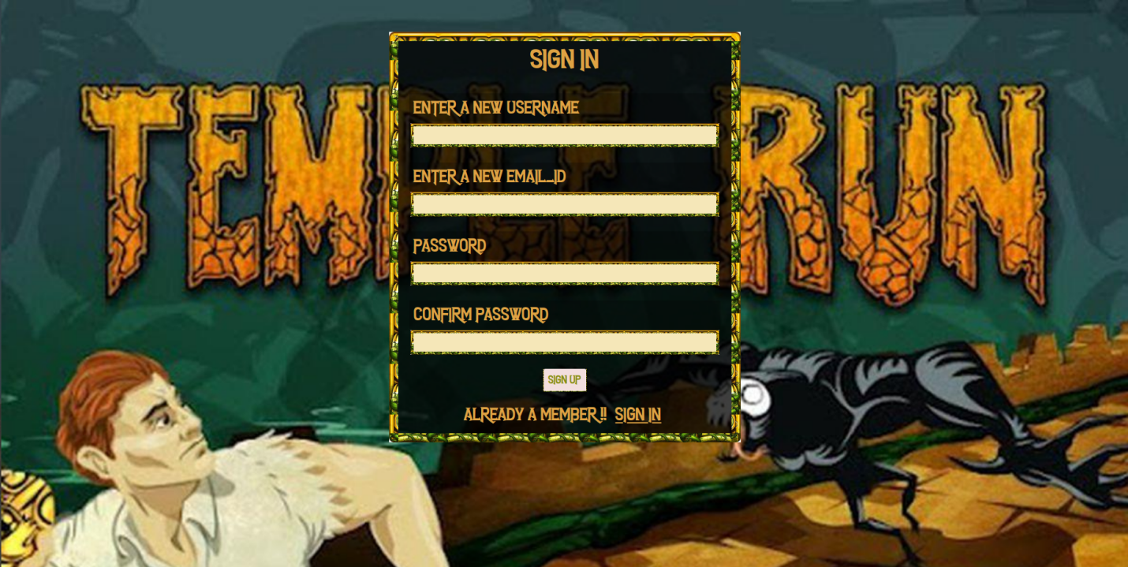

**CREATE QUERY PAGE**

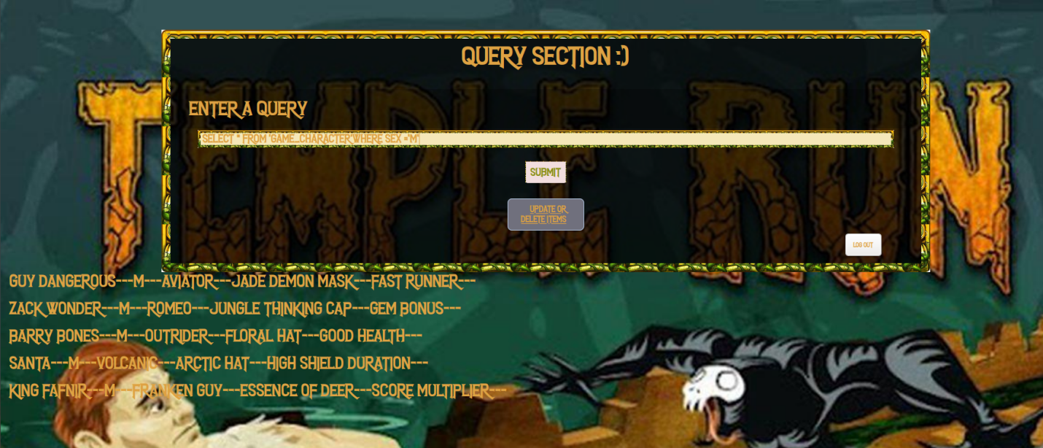

**UPDATE TABLES OPTION**

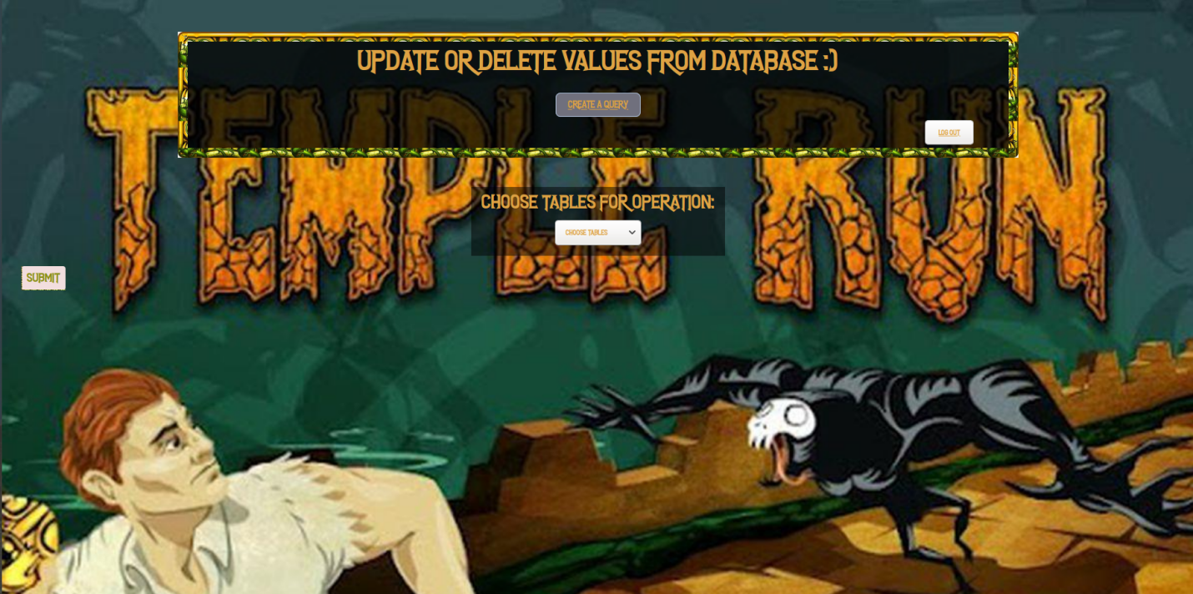

**USER DETAILS OPTION**

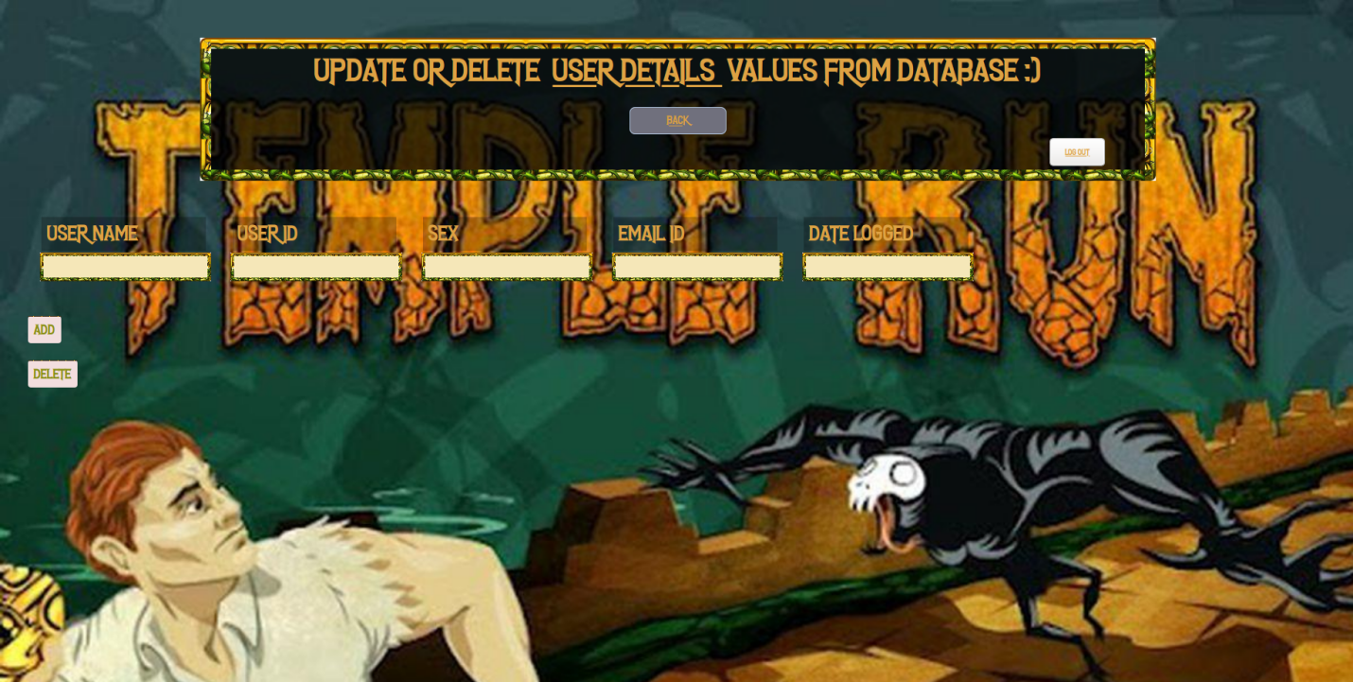

**OBJECTIVES**

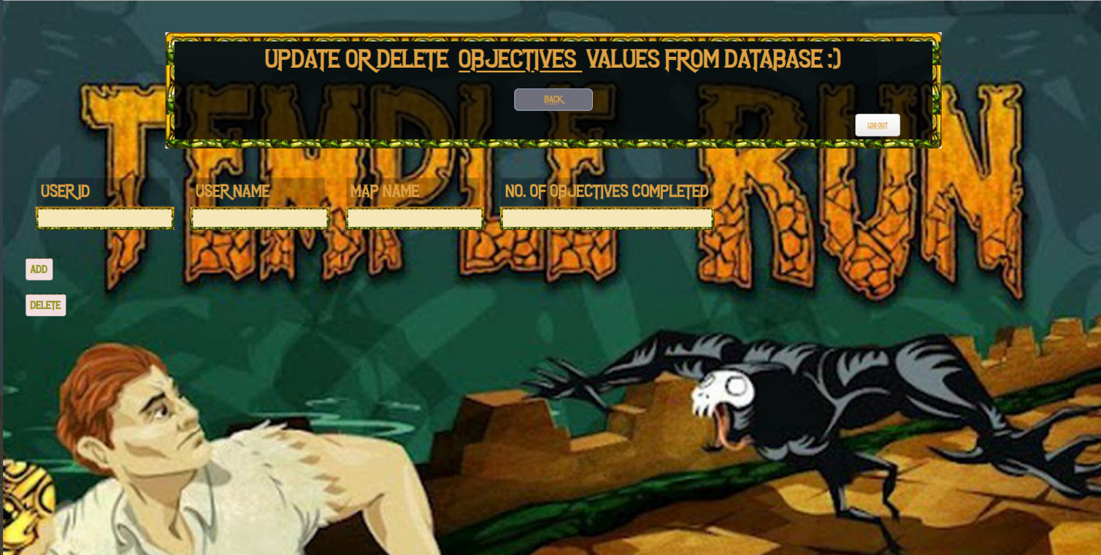

**5. CONCLUSION**

This project taught me about various concept about web handle and hosting using a localhost also it provides me with knowledge about php and connecting it with mysql and making a website with frontend and backend . This project was fun and with the help of our respected professor i was able to complete it with his guidance.

**6. REFERENCES**

Textbook:

[1] Leaning Web Design: A Beginner’s Guide

[2] SQL: The Ultimate Beginners Guide

Website:

[1] <https://www.tutorialspoint.com/html5/html5_web_sql.htm>

[2] <https://www.tutorialspoint.com/sql/sql-insert-query.htm>

[3] <https://www.w3schools.com/PHP/DEfaULT.asP>

[4] <https://www.onlineittuts.com/fetch-data-database-in-php.html>

[5] <https://www.tutorialrepublic.com/php-tutorial/php-mysql-insert-query.php>